“A MUSICAL FEAST”
APRIL 10, 2009 8 PM
GUSTO at the Gallery
Albright Art Knox Gallery 882.8700
Buffalo, NY Elmwood Avenue
Poetry with Vincent O’Neill
Co-sponsor: "The Robert and Carol Morris Center for 21st Century Music"
University at Buffalo
Co-sponsor: Irish Classical Theatre Company

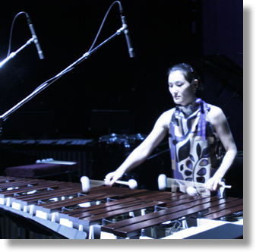
Charles Haupt, violin
Valerie Heywood, viola
Rin Ozaki, crotales
Alan Feinberg, piano
Jonathan Golove, cello
Tom Kolor, percussion
Christina Walsh, dance
Melanie Aceto, choreographer: dance

Iannis Xenakis W.A. Mozart J.A. Bach
J.T. Rinker Mario Lavista
Free Admission
www.amusicalfeast.com

